1. **Implement a Java program to find the factorial of a given number.**

**Answer:**

import java.util.*;

class Factorial

{

public static void main(String arg[])

{

Scanner sc = new Scanner(System.in);

System.out.println("Enter number");

int a = sc.nextInt();

int fact=1;

for(int i=1; i<=a; i++)

{

fact=fact*i;

}

System.out.println("Factorial is"+fact);

}

}

**Output:**

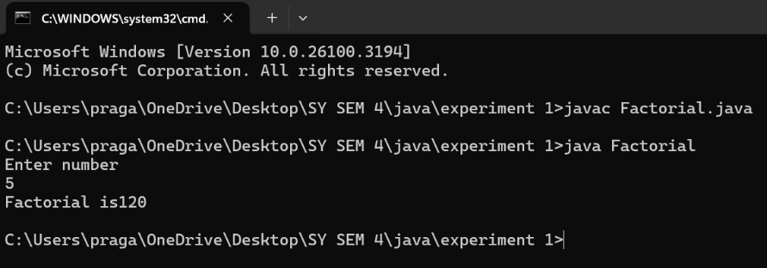

1. **Implement a Java program to check whether a given number is prime or not. (Take the number as a command-line argument.)**

**Answer:**

class PrimeCheck {

public static void main(String[] args) {

if (args.length == 0) {

System.out.println("Please provide a number as a command-line argument.");

return;

}

int num = Integer.parseInt(args[0]);

boolean isPrime = true;

if (num <= 1) {

isPrime = false;

}

else {

for (int i = 2; i <= Math.sqrt(num); i++) {

if (num % i == 0) {

isPrime = false;

break;

}

}

}

if (isPrime) {

System.out.println(num + " is a prime number.");

} else {

System.out.println(num + " is not a prime number.");

}

}

}

**Output:**

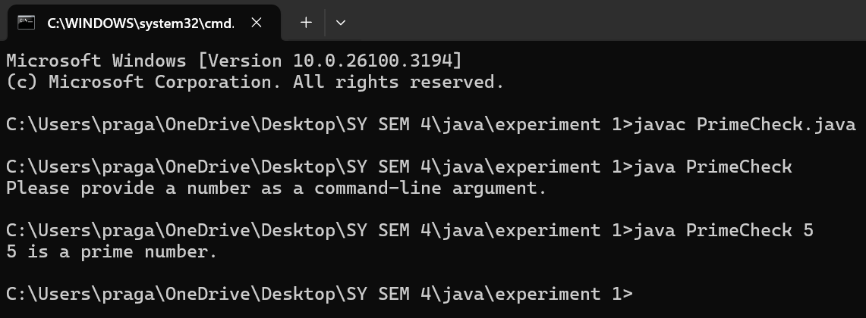

1. **Implement a Java program to sort a given list of 10 numbers in ascending order.**

**Answer:**

import java.util.Arrays;

import java.util.Scanner;

public class ascendingOrder {

public static void main(String[] args) {

Scanner sc = new Scanner(System.in);

int[] numbers = new int[10];

System.out.println("Enter 10 numbers:");

for (int i = 0; i < 10; i++) {

numbers[i] = sc.nextInt();

}

Arrays.sort(numbers);

System.out.println("Sorted numbers in ascending order:");

for (int num : numbers) {

System.out.print(num + " ");

}

sc.close();

}

}

**Output:**

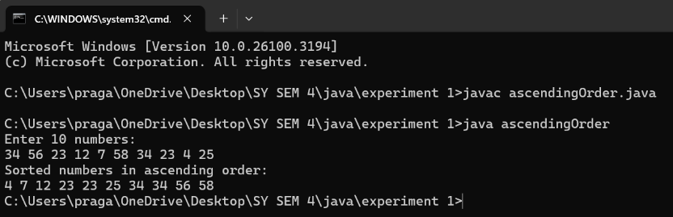

1. **Implement a Java program to merge two sorted arrays.**

**Answer:**

import java.util.Scanner;

class NumberSorting

{

public static void main(String[] args)

{

Scanner sc = new Scanner(System.in);

int k;

int j;

int i;

System.out.print("Enter the size of first sorted array: ");

int m = sc.nextInt();

System.out.print("Enter the size of second sorted array: ");

int n = sc.nextInt();

int[] a = new int[m];

int[] b = new int[n];

int[] c = new int[m + n];

System.out.println("Enter elements of first sorted array:");

for(i = 0; i<m; i++)

{

a[i] = sc.nextInt();

}

System.out.println("Enter elements of second sorted array:");

for(j = 0; j<n; j++)

{

b[j] = sc.nextInt();

}

i = 0;

j = 0;

k = 0;

while(i<m && j<n)

{

if(a[i]<b[j])

{

c[k++]=a[i++];

}

else

{

c[k++]=b[j++];

}

}

while(i<m)

{

c[k++]=a[i++];

}

while(j<n)

{

c[k++]=b[j++];

}

System.out.println("Sorted array is");

for(i=0; i<k; i++)

{

System.out.print(c[i]+"\t");

}

sc.close();

}

}

**Output:**

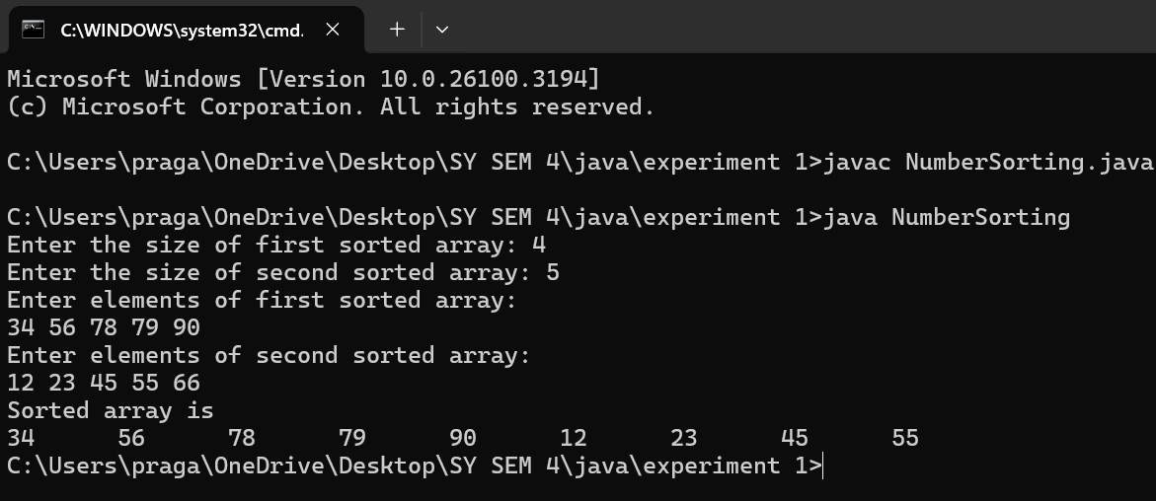

1. **Implement a Java program to perform 2×2 matrix multiplication, addition, and transpose (using a switch case).**

**Answer:**

import java.util.*;

class Matrix {

public static void main(String args[])

{

Scanner sc = new Scanner(System.in);

int a[][] = new int[2][2];

int b[][] = new int[2][2];

int result[][] = new int[2][2];

System.out.println("Enter elements of the first 2x2 matrix:");

for (int i = 0; i < 2; i++) {

for (int j = 0; j < 2; j++) {

a[i][j] = sc.nextInt();

}

}

System.out.println("Enter elements of the second 2x2 matrix:");

for (int i = 0; i < 2; i++) {

for (int j = 0; j < 2; j++) {

b[i][j] = sc.nextInt();

}

}

System.out.println("Choose an operation: ");

System.out.println("1. Addition");

System.out.println("2. Subtraction");

System.out.println("3. Multiplication");

System.out.println("4. Transpose of first matrix");

int choice = sc.nextInt();

switch (choice) {

case 1:

for (int i = 0; i < 2; i++) {

for (int j = 0; j < 2; j++) {

result[i][j] = a[i][j] + b[i][j];

}

}

System.out.println("Resultant Matrix after Addition:");

break;

case 2:

for (int i = 0; i < 2; i++) {

for (int j = 0; j < 2; j++) {

result[i][j] = a[i][j] - b[i][j];

}

}

System.out.println("Resultant Matrix after Subtraction:");

break;

case 3:

for (int i = 0; i < 2; i++) {

for (int j = 0; j < 2; j++) {

result[i][j] = 0;

for (int k = 0; k < 2; k++) {

result[i][j] += a[i][k] * b[k][j];

}

}

}

System.out.println("Resultant Matrix after Multiplication:");

break;

case 4:

System.out.println("Transpose of the first matrix:");

for (int i = 0; i < 2; i++) {

for (int j = 0; j < 2; j++) {

System.out.print(a[j][i] + " ");

}

System.out.println();

}

sc.close();

return;

default:

System.out.println("Invalid choice!");

sc.close();

return;

}

for (int i = 0; i < 2; i++) {

for (int j = 0; j < 2; j++) {

System.out.print(result[i][j] + " ");

}

System.out.println();

}

sc.close();

}

}

**Output:**

